Trường TH Dương Hà
PHẾU ÔN TẬP
Môn: Tiếng Anh - Tuần 2 ( Từ 10/2/2020 - 14/2/2020)
Ex1. Circle the odd one out: (Khoanh tròn từ khác biệt)
- A. mother B. father C. uncle D. brother
- A. grandfather B. brother C. grandmother D. teacher
- A. sister B. brother C. friend D. mother
- A. family B. Mummy C. Baby D. Daddy
- A. daughter B. uncle C. son D. baby
- A. house B. bedroom C. garage D. kitchen
- A. bathroom B. school C. bedroom D. dining room
- A. kitchen B. dining room C. library D. living room
- A. class room B. bathroom C. living room D. bedroom
- A. table B. chair C. garden D. desk
Ex2. Read the text carefully then answer the questions below:
My name is Tony. I am nine years old. I am in the picture with my relative. This is my uncle Tim. He is twenty nine years old. This is my aunt Tina. She is twenty-eight years old. This is my cousin Pat. He is thirteen years old. This is my cousin Jill. She is three years old. I like to play with Pat and Jill.
- How old is Tony?
- How old is uncle Tim?
- How old is aunt Tina?
- How old is Pat?
- How old is Jill?
Ex3. Reorder these words to make meaningful sentences:
- Small/ is/ this/ house/ a/.
- a/ living/ large/ room/ is/ this.
- There/ is/ in/ house/ the/ bedroom/ a/ ?
- Pond/ in/ garden/ the/ is/ a/ there/.
- Kitchen/ the/ old/ is/.
- Room/ living/ the/ large/ is/. ……………………………………………………………
Ex4. Read and tick (v)
Hi! My name is Lan. This is my house. It is big. There is a garden in front of the house. There are trees in the garden. There is not a garage. The living room is large ,but the kitchen small. There are four bedrooms, two bathrooms in my house. There is a pond behind the house. Around the pond, there are many trees and flowers. They are very beautiful.
 | Yes | No
- Lan’s house is small.
- The garden is behind the house.
- The living room is large.
- There are many rooms in Lan's house.
- There is a pond in front of her house.
Ex5. Translate into English:
- Tớ thích chơi bịt mắt bắt dê.

- Ông của bạn bao nhiêu tuổi?

- Ông của tớ 78 tuổi.

- Đây là phòng khách.

- Nó rất đẹp!

Ex6.Choose the word different from others in each line.
1. A. pen B. ruler C. eraser D. school
2. A. tall B. big C. old D. bag
3. A. child B. cakes C. candies D. books
4. A. father B. sister C. son D. friend
5. A. cat B. dog C. buffalo D. fish
Ex7. Choose one word to complete the sentence.
1. - What are Peter and Jane doing?
- They are …………….. volleyball.
A. playing B. play
2. - What is he doing?
- He …………….. playing with paper boats.
A. are B. is
3. - Where are they now?
- They are …………….. the garden.
A. in B. on
4. - Are they playing badminton?
- Yes, they
A. aren’t B. are
5. - Is she skipping?
- No, she …………….. She is cycling.
A. isn’t B. is
Ex8. Look at the picture and the letters. Write the words.
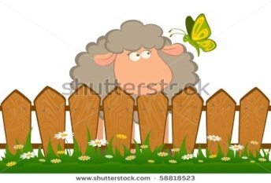  1. enfec____________________ | 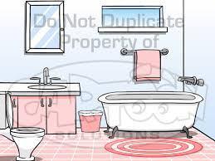  2. tboarmho _____________________
  3. eplan _______________________ | 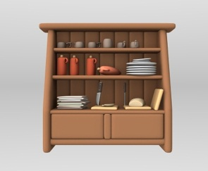  4. brpcaou ____________________
Ex9. Read the passage and write Yes or No.
This is my living room. There are many things in the room. There are three windows and a door. There is a table, six sofas and two chairs. There is a lamp on the table and a TV on the cupboard. There are two pictures, a fan and a clock on the wall.
 | Yes | No
1. This is the living room.
2. There are two windows.
3. There is a sofa.
4. The lamp is on the table.
5. The fan is above the wall.
Ex10. Reorder the words.

1. this/ ?/ who/ is/
____________________________________________________________________
2. my/ ./ she/ sister / is/
____________________________________________________________________
3. is/ ./ this/ house/ my/
____________________________________________________________________ 4. is/./ dining/ a/ room/ there/
____________________________________________________________________
5. the/ ?/ is/ where/ poster/
___________________________________________________________________
6. on/ ./ it’s/ wall/ the/
____________________________________________________________________
7. many/ ?/ there/ fans/ how/ are/
____________________________________________________________________
8. six/./ there/ are/
____________________________________________________________________

